Test Case: tc003_SPX_Dev5_Crear_Requisicion_Spot_Tipo_Cobro_CC_Urgent
Step 1 - Enter username and password and click to button Enter : Credentials Entered
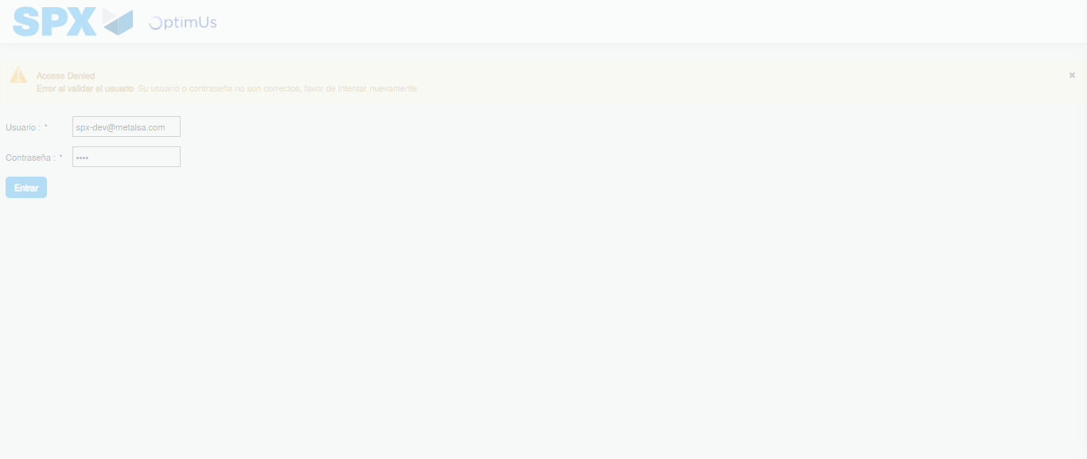Image file-name: QC_Testing-tc003_SPX_Dev5_Crear_Requisicion_Spot_Tipo_Cobro_CC_Urgent-1783356700993

Step 2 - Select to UEN and Access to Spot Buy Requisitions : UEN Correctly selected and Correct access
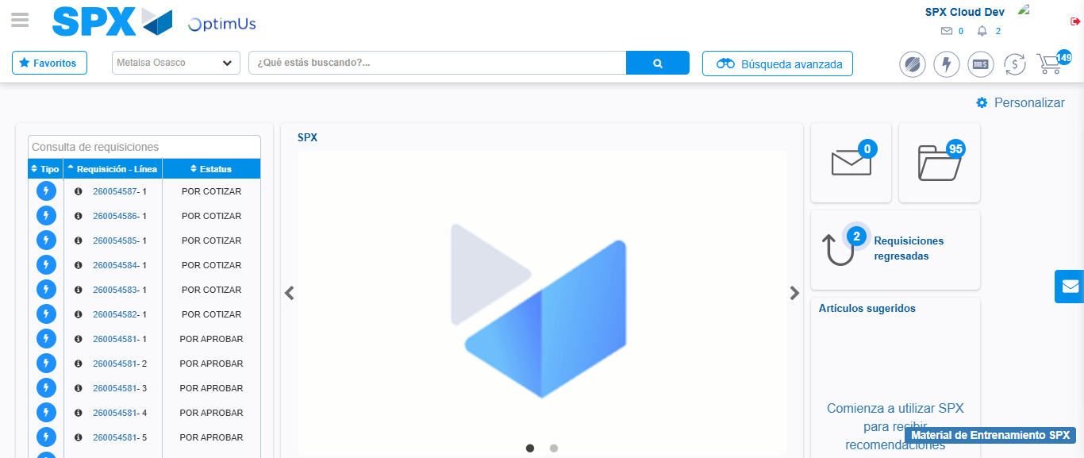Image file-name: QC_Testing-tc003_SPX_Dev5_Crear_Requisicion_Spot_Tipo_Cobro_CC_Urgent-1783356727206

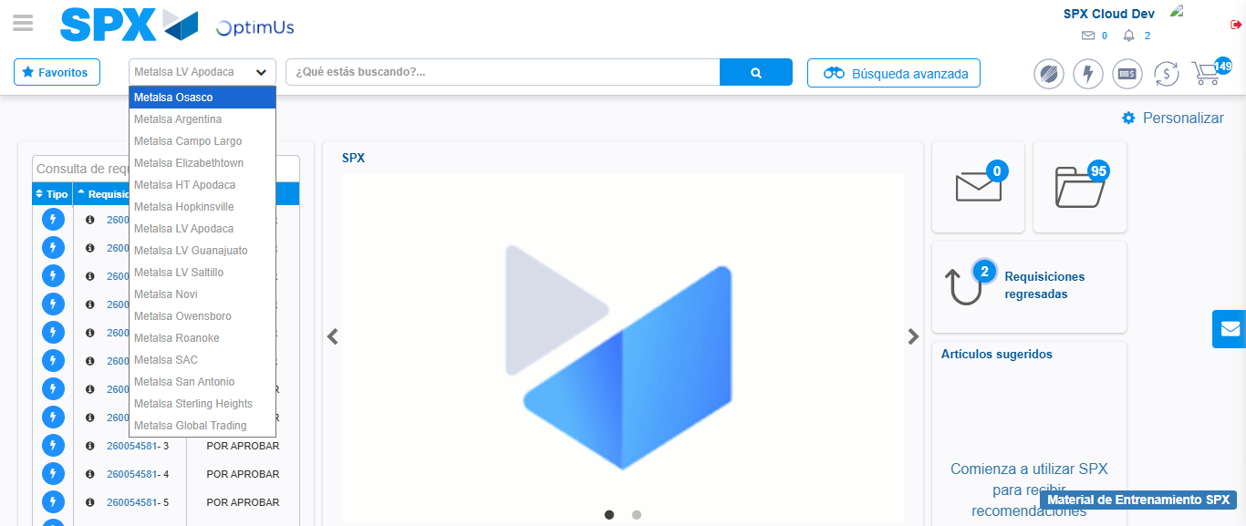Image file-name: QC_Testing-tc003_SPX_Dev5_Crear_Requisicion_Spot_Tipo_Cobro_CC_Urgent-1783356730111

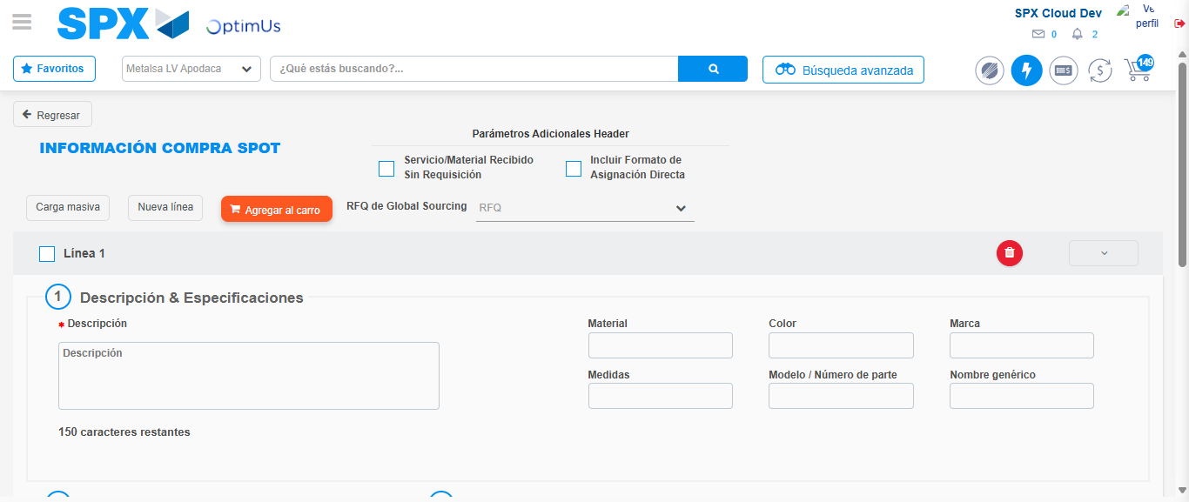Image file-name: QC_Testing-tc003_SPX_Dev5_Crear_Requisicion_Spot_Tipo_Cobro_CC_Urgent-1783356749974

Step 3 - Data Capture Spot Buy Requisition: Data captured correctly
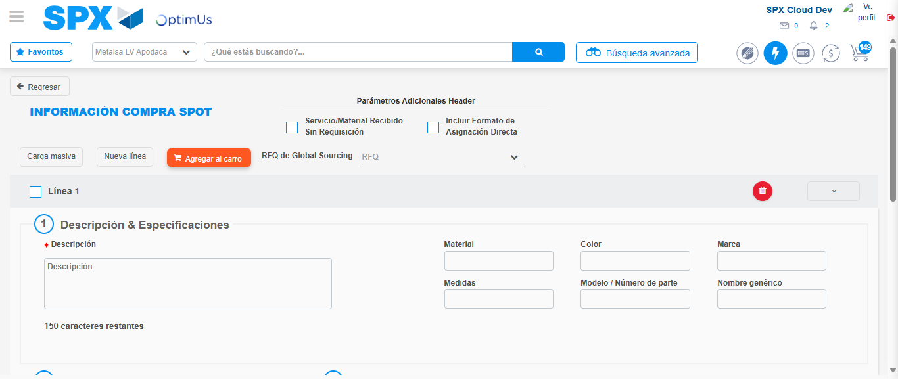Image file-name: QC_Testing-tc003_SPX_Dev5_Crear_Requisicion_Spot_Tipo_Cobro_CC_Urgent-1783356750245

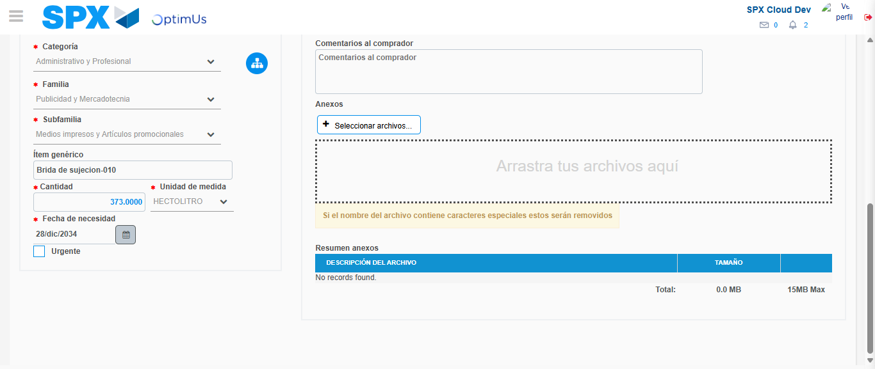Image file-name: QC_Testing-tc003_SPX_Dev5_Crear_Requisicion_Spot_Tipo_Cobro_CC_Urgent-1783356762706

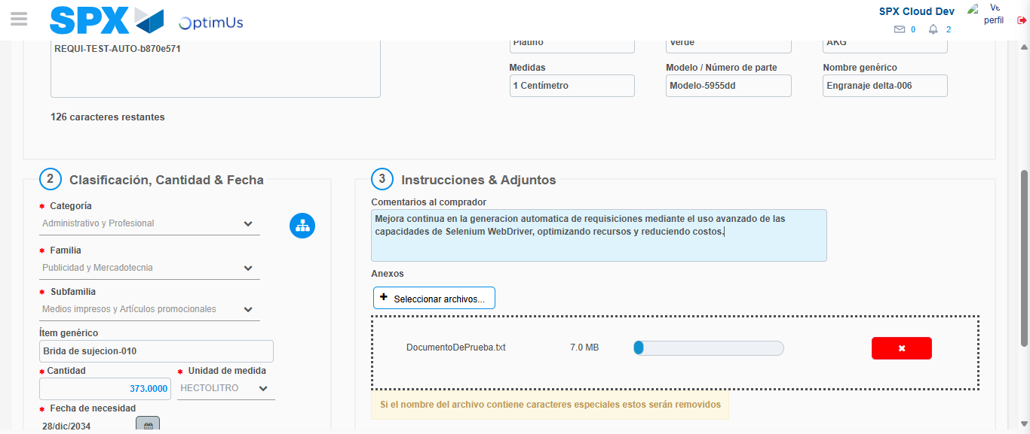Image file-name: QC_Testing-tc003_SPX_Dev5_Crear_Requisicion_Spot_Tipo_Cobro_CC_Urgent-1783356763786

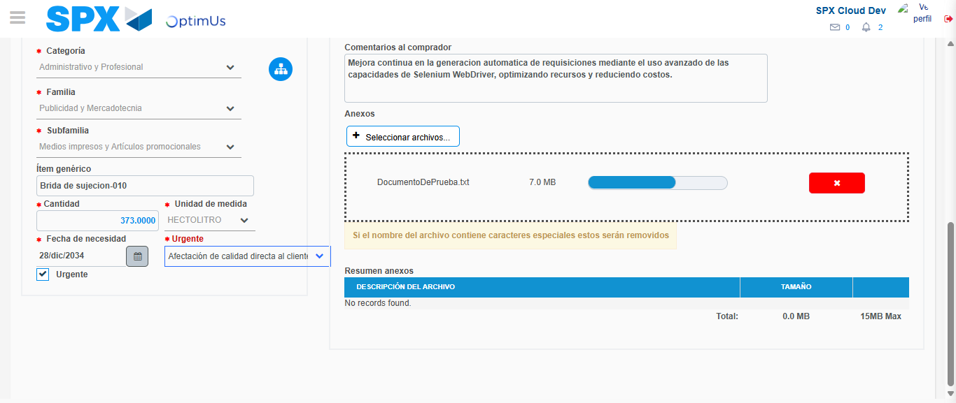Image file-name: QC_Testing-tc003_SPX_Dev5_Crear_Requisicion_Spot_Tipo_Cobro_CC_Urgent-1783356767861

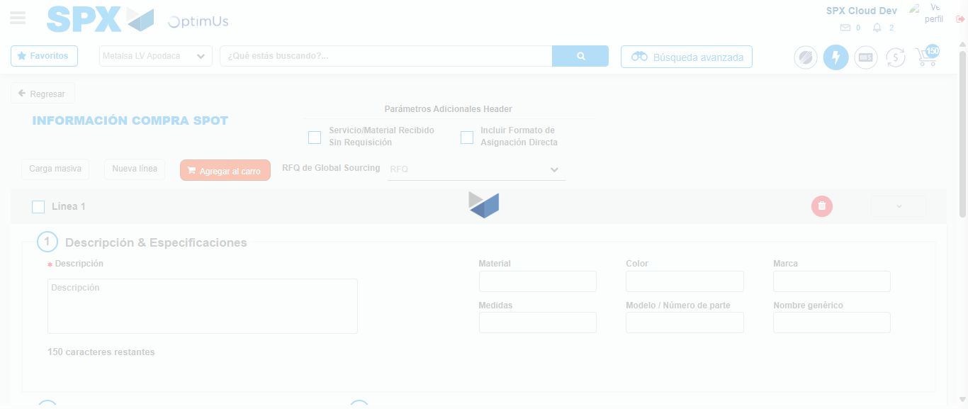Image file-name: QC_Testing-tc003_SPX_Dev5_Crear_Requisicion_Spot_Tipo_Cobro_CC_Urgent-1783356776849

Step 7 - Return to Main Page SPX : Return to Main Page SPX
Image file-name: QC_Testing-tc003_SPX_Dev5_Crear_Requisicion_Spot_Tipo_Cobro_CC_Urgent-1783356727206

Image file-name: QC_Testing-tc003_SPX_Dev5_Crear_Requisicion_Spot_Tipo_Cobro_CC_Urgent-1783356730111

Image file-name: QC_Testing-tc003_SPX_Dev5_Crear_Requisicion_Spot_Tipo_Cobro_CC_Urgent-1783356749974

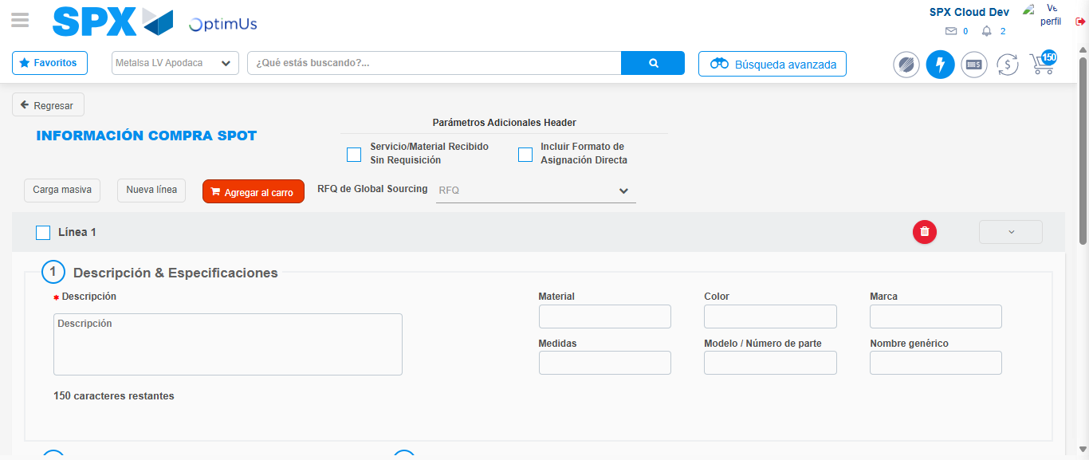Image file-name: QC_Testing-tc003_SPX_Dev5_Crear_Requisicion_Spot_Tipo_Cobro_CC_Urgent-1783356779129

Image file-name: QC_Testing-tc003_SPX_Dev5_Crear_Requisicion_Spot_Tipo_Cobro_CC_Urgent-1783356779339

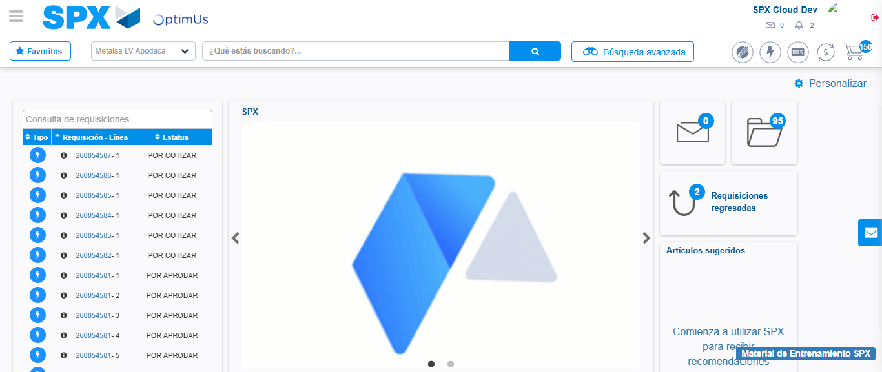Image file-name: QC_Testing-tc003_SPX_Dev5_Crear_Requisicion_Spot_Tipo_Cobro_CC_Urgent-1783356800721

Step 8 - Log Out : Log Out SPX
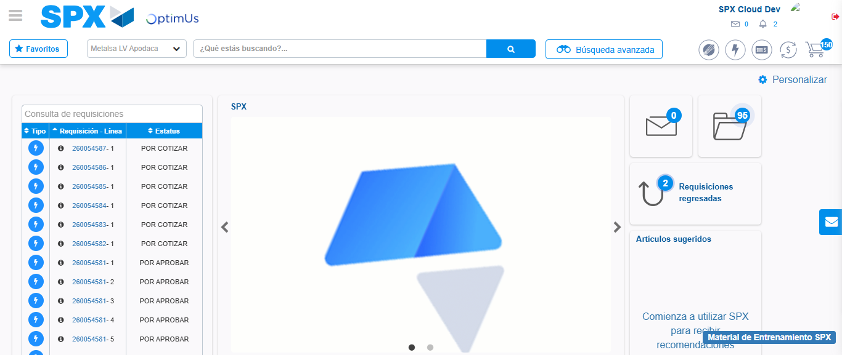Image file-name: QC_Testing-tc003_SPX_Dev5_Crear_Requisicion_Spot_Tipo_Cobro_CC_Urgent-1783356801088

